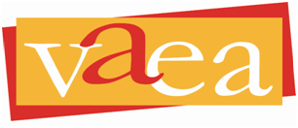
Virginia Art Education Association
To promote, support and advance visual arts education through professional development, leadership, research and service.

February 7, 2024

Dear School Administrator:

I am pleased to announce the 2024 Virginia Art Education Association Professional Development Conference will be held in Reston, VA, November 7 - 9.

This annual gathering of as many as 300 visual arts, design, and media arts educators, including prekindergarten-12 art teachers, school division administrators, college and university faculty, and museum and preservice educators, provides the most comprehensive opportunity for professional development related to our field in the Commonwealth. The VAEA has hosted over 50 professional conferences and this year promises to be an event not to be missed.

Conference opportunities include over 100 sessions that showcase the latest in research and effective practice and provide interactive learning through discussion and hands-on workshops. All program events are 100% art education content that can be applied immediately to teaching and learning.

As educators, in this climate of high-stakes testing, we know that the arts are critically important in developing human potential in our students. I ask for your encouragement and support of art educators in further advancing their knowledge and professional skills by providing release time and support for their participation, travel, and lodging.

The program will be open for registration in August. The registration costs and the individual session list will be available on the VAEA website – www.vaea.org. Feel free to contact me at cherylmiehl@gmail.com if you require further information.

We look forward to providing a valuable and timely professional experience for your art educators. I thank you for your leadership as we work together toward ensuring quality education for our nation’s youngest citizens — all of our students.

Sincerely,
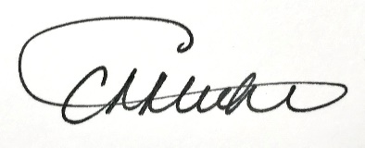

Holly Bess Kincaid
Cheryl Miehl
VAEA President

