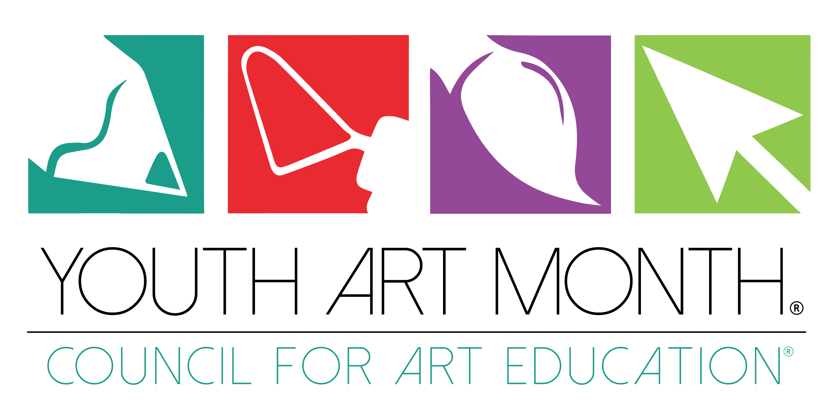

Sample Proclamation
WHEREAS: The study of art leads to a fuller, more meaningful life; and
WHEREAS: Art education provides substantial educational benefits to all elementary, middle and secondary students; and
WHEREAS: Art education develops students’ creative potential and improves problem-solving and critical thinking skills by reinforcing and bringing to life what students learn in other subjects; and
WHEREAS: Art education teaches sensitivity to beauty, order and other expressive qualities, and also gives students a deeper understanding of multi-cultural values and beliefs; and
WHEREAS: Art education advances student mastery in art production, art history, art criticism and aesthetics; and
WHEREAS: Our national leaders have acknowledged the necessity of including art s experiences in all students’ education; and
WHEREAS: The National Art Education Association, in conjunction with the (ENTER STATE ORGANIZATION NAME) strives to improve the well being of our communities by upgrading visual awareness of the cultural strengths of (ENTER CITY, STATE) and the United States as a whole; and
WHEREAS: The residents of (ENTER STATE) have joined the National Art Education Association and the (ENTER STATE ORGANIZATION NAME) in supporting the youth of our community in their intellectual development through artistic endeavors, and offering support to our committed art teachers

NOW, THEREFORE, I, (NAME OF GOVERNOR/MAYOR/), GOVERNOR/MAYOR OF THE STATE/CITY OF (ENTER STATE/CITY), do hereby proclaim March (YEAR) as YOUTH ART MONTH. All residents are urged to give their full support to quality school arts programs for our youth.
Dated this (ENTER DATE)

